# **Appendix I. Web pages**



Fig A-1. Home page of Pet Club

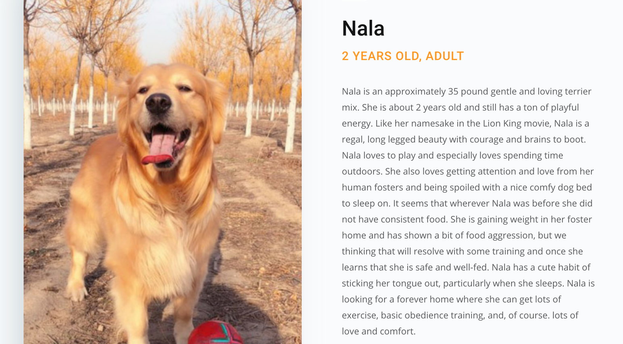

Fig A-2. Introduction of pet

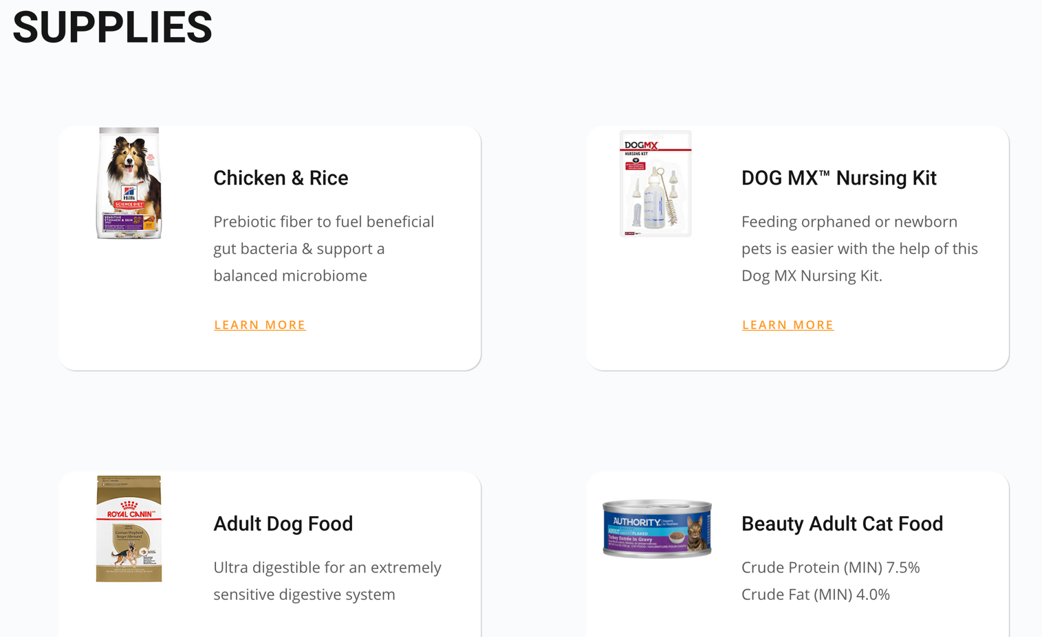

Fig A-3. Supplies



Fig A-4. Members

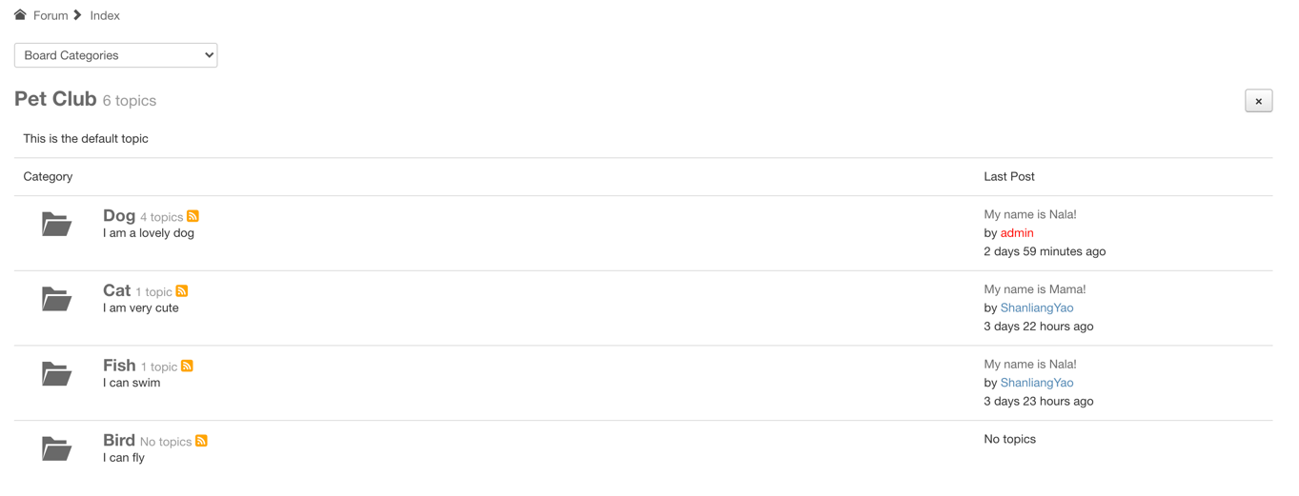

Fig A-5. Categories of forum

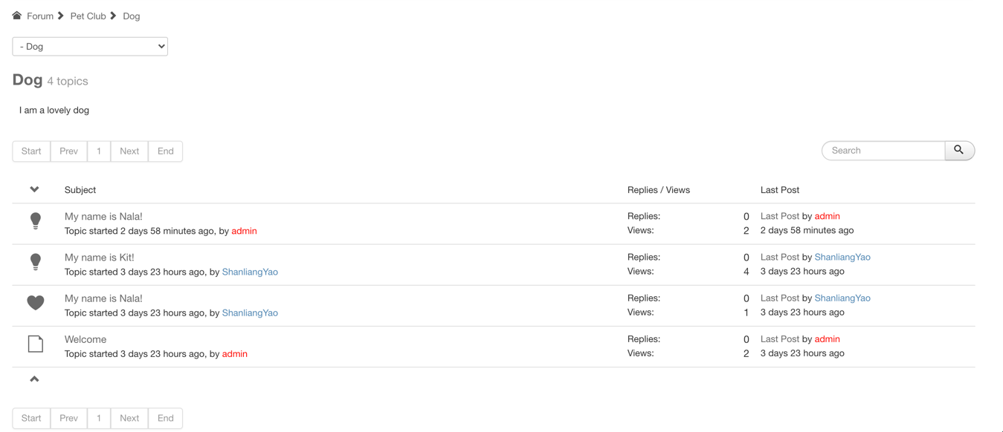

Fig A-6. Topics of category dog

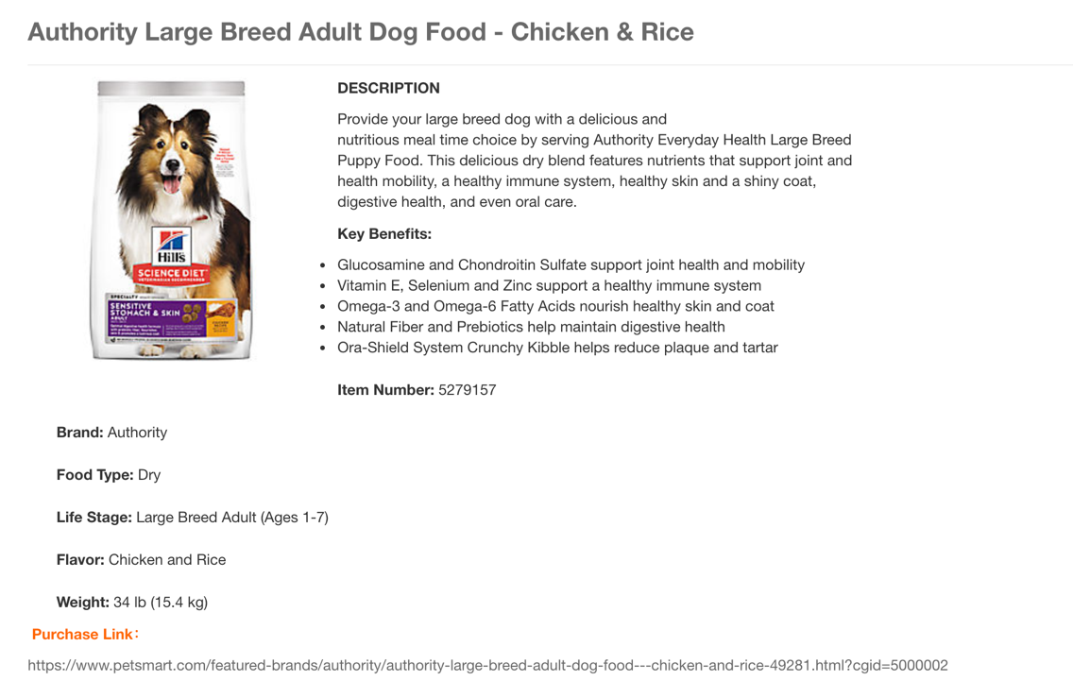

Fig A-7. Detail information of supply

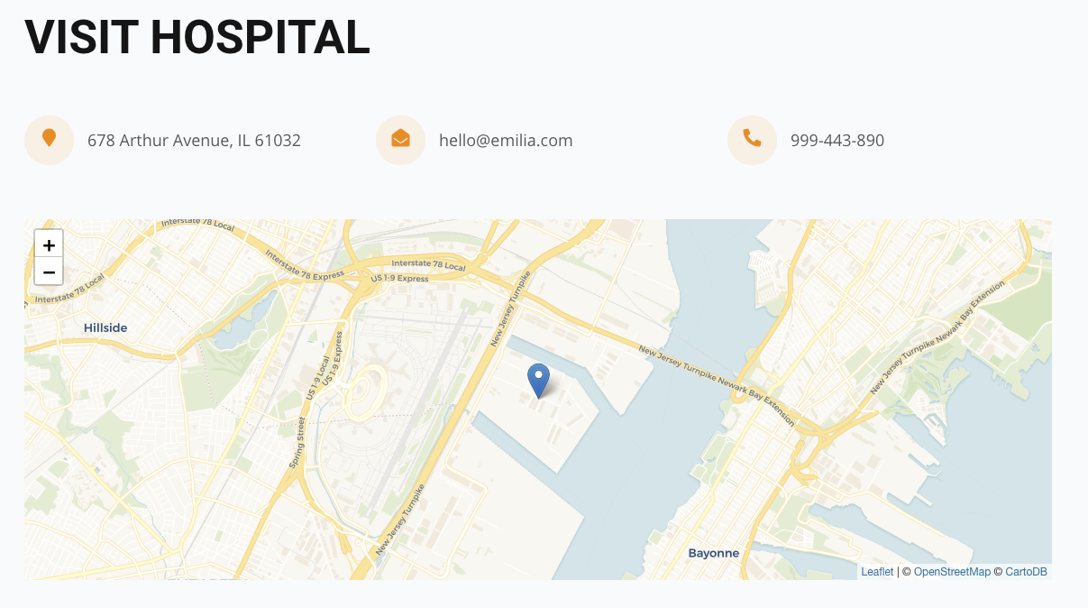

Fig A-8. Map of hospital

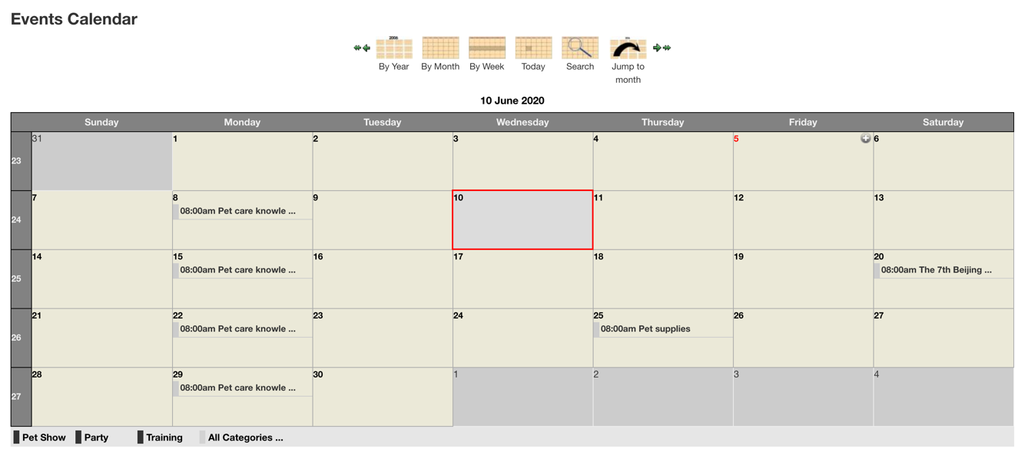

Fig A-9. Activities from the Event Calendar